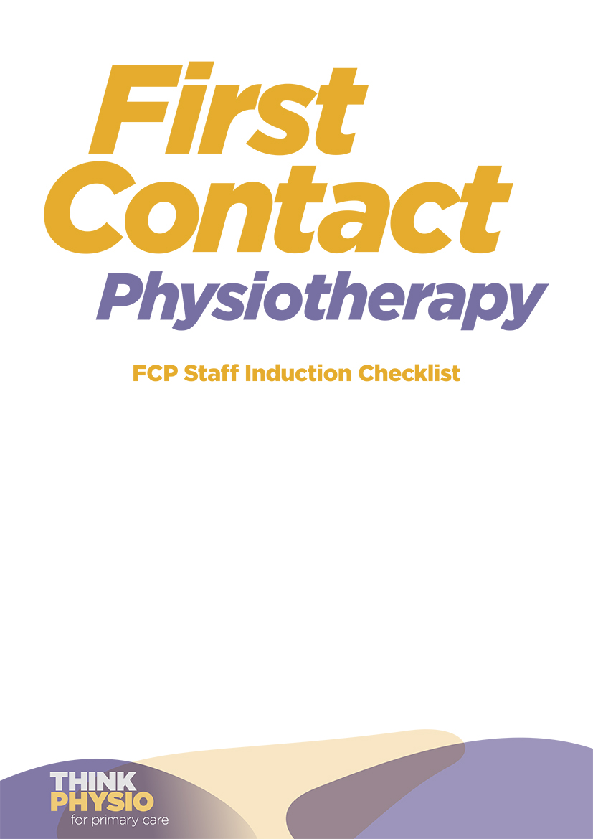

This is an example checklist. As induction practices vary between employers and job roles (and on whether the FCP is contracted by a provider or employed directly), please adapt as required.

Introductions | Date(s) completed | Notes
Introductions to Practice team including practice manager, reception staff, secretaries, and IT support staff
Introductions to clinicians within the multi-disciplinary team (MDT), for example: GPs, nurses, healthcare assistants, paramedics, pharmacist, phlebotomist and patient participation groups
One-to-one introductions with key staff
Shadowing appropriate staff (e.g. GP, practice nurse, FCP in another practice)
Explanation of organisational structure and committee structures, systems and processes (GP PCN/Cluster/Federation/Trust structure)
Introduction to Patient Participation Groups (PPG) in GP surgery
Workplace orientation and risk management | Date completed | Notes
Security induction (including doors, keys, alarms, access codes and security of personal items)
Health and safety induction (including emergency contact and fire procedures)
Practice opening times
Tour of the workplace including clinical rooms, admin rooms, kitchen, toilet, parking area and special requirements facilities (such as hearing loop, large print resources)
Orientation of the practice’s key documents and where to find them
ID badge or pass (if relevant)
Explanation of how to order / access clinical equipment (e.g. injection equipment, thermometer, BP sphygmomanometer)
Explanation of how to access an interpreter or chaperone
Procedures for patient and staff emergencies (including alarms and anaphylactic and cardiac arrest equipment)
Information on how to access improving access equipment (e.g. interpreting services and hearing loops)
Infection control policy and introduction to lead clinician
Health and safety policy and introduction to lead clinician
Lone working policy
Procedure for face to face, video and phone consultations (including any decision making tools or risk assessment tool/risk register)
IT and phone systems | Date completed | Notes
Access and induction to a computer (with user account and password)
Access and induction to the Practice’s telephone system
Access to the Practice’s email system and GP email network
Access to a Smart card (particularly if working across multiple practices)
Access and induction to the Electronic Patient Record (EPR) system
Access to clinical information systems
Arrange access to local folders for data storage and patient information leaflets
Arrange Prescribing authorisation / scripts
Explanation of procedures for communicating with MDT and training as required (e.g. using EPR system, direct messaging)
Explanations of procedures for patient correspondence (phone, email, accurx etc)
Patient referral and review processes | Date completed | Notes
Procedure for booking with GP for emergency and routine follow-ups
Procedure for booking with other primary care staff: nurses, ANPs, pharmacists, paramedics, social prescribers etc
Access to existing letter templates or methods for:
- Secondary care referrals (and awareness of local clinical pathways)
- Urgent and emergency referrals
- MSK physiotherapy (both outpatient and community)
- Other re-ablement services (e.g. falls services / occupational therapy / podiatry)
- Talking therapies / mental health services
- Smoking cessation / dietician / exercise referral
- Local services for social prescribing (including key NHS, social and voluntary organisations in the area and how to signpost)
- Patient and citizen safety procedures: mental health, addiction, violence, suicide risk
- Clinical/medical emergency plan: adverse drug reactions, anaphalaxysis, red flags, cardiac arrest, first aid and medical kit etc.
Investigations and interventions | Date completed | Notes
Familiarisation with:
- PGD and injection equipment and medicines
- Aspiration protocol
- Standard operation procedures for requesting and interpreting radiological investigations
- Standard operation procedures for ordering and interpreting blood tests
- Fit note procedures and consideration of AHP health and work report
- The process for issuing or obtaining prescriptions
- Awareness of the local and National formularies and local medicines management
Governance | Date completed | Notes
Review of the FCP’s job description and service specification. Examples can be found here
Review of diary template and job plan (including CPD, meetings and supervision)
Explain policies and procedures regarding sickness and absence
Review of Health Education England Roadmap (if in England), AHP Framework (if in Wales), Scottish education quality framework (if in Scotland) and Advanced AHP framework (if in NI)
Arrangements for appraisal and 1:1 line management meetings
Arrangements for mandatory training
Familiarisation with mechanisms for reporting and managing risks, incidents and complaints (including safeguarding and whistleblowing/freedom to speak up)
Review of data collection mechanisms and responsibilities
Review of patient orientated outcome measures
Familiarisation of documentation procedures, standard and audit
Aware of PLI cover (depending on employment model)

